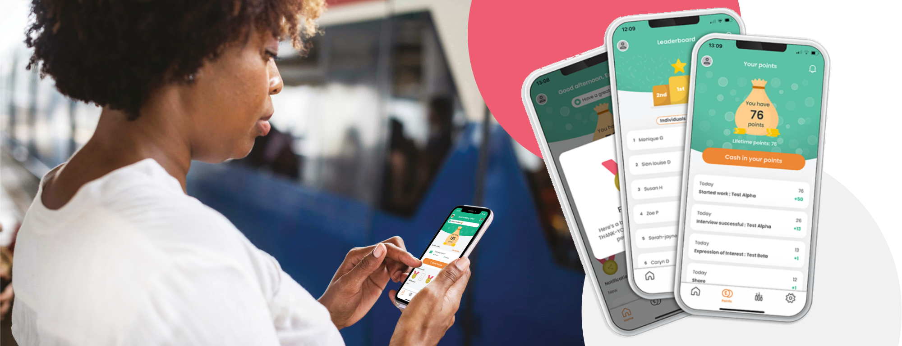

[Company Name] Staff
Referral & Reward Program

To our Care Friends Champions,
Caring People know Caring People
Employee referrals are proven to be the best way to source quality staff with higher retention rates. Our own staff have vast networks of potential employees, and we want to tap into these.
As mentioned in an earlier email, we are going to turbocharge our referral scheme by launching Care Friends, a brand-new employee referral and reward app for the Care Sector. Care Friends makes it super easy for our staff to share jobs plus fun and rewarding.
Watch the short intro video

Morning Tea Info
On [DATE] we will launch Care Friends and that morning all eligible employees will receive a text message invite on their personal phones to download the app. Although we cannot control the exact time these text messages arrive, most employees will receive it that morning between 9am and 11am.
To add a bit of oomph to the launch, we will provide you with some treats to host a morning tea for all available employees. During the morning tea, your manager will introduce Care Friends to the team, however we also need your help.
Firstly, if you haven’t already done so, please download the Care Friends app before this meeting and familiarise yourself with it.
Secondly, during this morning team launch, we ask you to be on site to help employees with downloading the app and showing them how to use it, if needed. Remember, the more people who sign up at your site, the bigger your reward for being a Champion!
A previous email included more detail on Care Friends but feel free to contact us directly if you have any further questions.
Please liaise with your manager about the exact time and location of the morning tea.

Thank you in advance for making a success of this important new resource!

