Click on this link to access the Canva template of this document or scroll down to edit the Word version:

<https://www.canva.com/design/DAFIyb9tYCY/OxVo8VuHm0qdkQoxgH-Ofw/view?utm_content=DAFIyb9tYCY&utm_campaign=designshare&utm_medium=link&utm_source=publishsharelink&mode=preview>

Sign in required.

The document is an A5 flyer with full bleed.

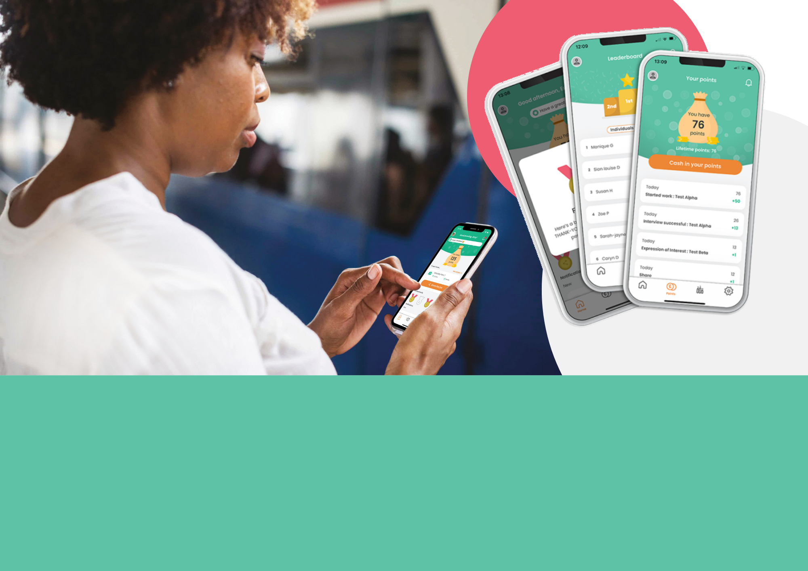

We are always looking for more amazing team members like you and we want to make it easy, fun and rewarding to recommend our jobs to people in your network. So, on [DATE] we’re relaunching our employee referral and reward app, called Care Friends. Stay tuned for more info!

Help us find more great people like you and be rewarded!