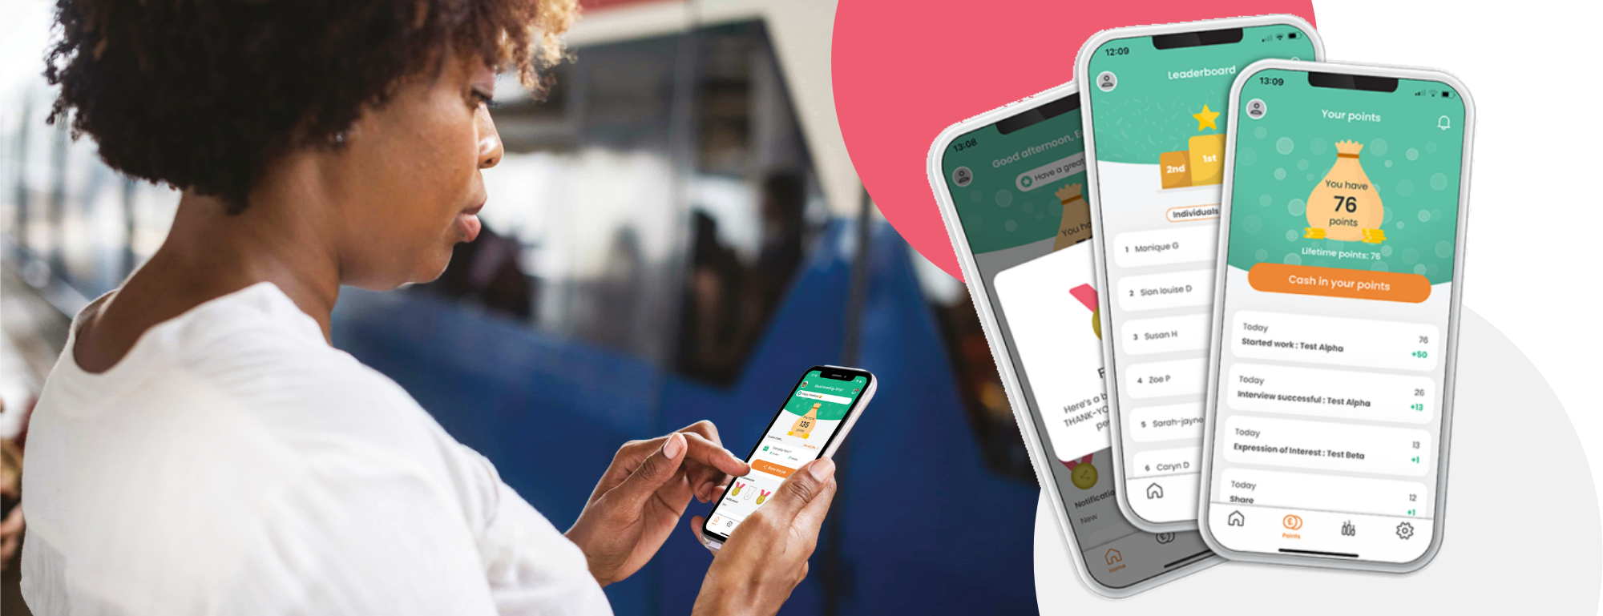

[Company Name] Staff
Referral & Reward Program

To our Managers,
Caring People know Caring People
Employee referrals are proven to be the best way to source quality staff with higher retention rates. Our own staff have vast networks of potential employees, and we want leverage these.
You may be aware that we have an employee referral scheme that is managed via Care Friends, a brand-new employee referral and reward app for the Care Sector. Care Friends makes it super easy for our staff to share jobs plus fun and rewarding.
We introduced Care Friends on [DATE] and so far we have received XX referrals and hired XX of these referred candidates. This is amazing news as the time to hire for a referral is shorter than for candidates from other sources. In addition, referred employees, on average, have a longer tenure! Plus, we would rather reward our own staff for candidates, than online job boards or agencies.
Although we have received some excellent quantity and quality referrals, not all our employees have the app downloaded on their phone. To increase our reach into these passive job seekers from our employees’ network, we are relaunching Care Friends on [DATE]. On this day, we will organise a morning tea and all employees will receive a text invite on their phone to download the app.
Watch the short intro video

- Please note that we need your help and have more detail further down this email. Please do read this.

What are our referral rewards?
Just for downloading the app, we reward staff with XX points. Care Friends uses micro-rewards to promote quality referrals, so for each step in the recruitment process a referral successfully completes, the referrer gets more points.
1 point is worth $1!
Action | Points
Download and register for the app | XX
Share a job | 1
Your referral applies | XX
Your referral has a successful interview | XX
Your referral completes their first day on the job | XX
BONUS if your referral is NEW to the care sector | XX
Your referral reaches XX months of employment | XX

Once an employee reaches XX points, they can choose to cash in these points and the value of the points will be added to their next pay (minus any applicable taxes or deductions).

Relaunch Day: [date]

Who manages referrals?
Employee referrals are managed by our central Talent Team. Nothing will change for you in the recruitment process. As always, we will need your support by being available to interview candidates and provide feedback after the job interview as soon as possible. In this candidate scarce market, time is of the essence.
Employee referrals are managed by a dedicated person at each of our locations. Care Friends comes with its own referral platform, connected to the employee app, that makes managing jobs and referrals a breeze.
As we have integrated the Care Friends app with our ATS [ATS NAME], referrals will pop in there as per the normal recruitment process. We just want to reinforce the importance of timely updates to the candidates’ recruitment status, as these updates are now directly linked to the allocation of points to the referring employee via the app.
Extra rewards!
We also use Care Friends to give out rewards that are not referral-related. We call them Bonus Points. For example, our employee-of-the-month reward will now be paid out via Care Friends. To fund this, each department will get a monthly budget of XX points to use for Bonus Points.
We have created the following reward categories for you in the Care Friends portal.
Action | Points
Excellent client feedback | xx
Going over and above | xx
Taking on a last-minute shift | xx
Helping a colleague in need | xx
Other, up to manager discretion | xx
Employee of the month | xx

Bonus Points are managed by line managers and as such you might require access to the Care Friends manager portal. Although assigning bonus points is quite easy, we do require you to complete some short online training on how to do this. More info to follow.

How to download the app?
On relaunch day, all eligible employees will receive a text message on their personal mobile with a link to the app. Alternatively they can download the app from their app store or scan a QR code that we provide them with. We recommend you download the app as well.

Who is eligible?
- All permanent, part-time, casual staff are eligible to refer as long as they are not directly involved in the recruitment process for the job

Some rules
- No internal referrals
- The referral must be qualified and eligible for the role
- If a candidate is ineligible, awarded points may be deducted
- The referral must live within a reasonable commutable distance to the job
- Must not have applied for a role with us in the past 6 months
- You can choose to cash-in your points once you reach XX points
You can view all rules from within the app.

What we need from you
As mentioned, employee referrals are more likely to be high quality staff that stay longer, so it is worth investing in this underutilised source of staff. The more employees register to the app, the more referrals we get.
What we need from you:
- Promote Care Friends during relaunch day and team meetings
- Help employees download the app where needed
- Use the Bonus Points budget each month
- Walk the talk: download the app yourself!
We will officially relaunch Care Friends on [DATE], which includes the text invite to download the app. We need your help on this day by getting your staff together for a morning tea and to introduce them to this new initiative.
If haven’t marked this date in your calendar, please do this now.
- We also now require you to send out a meeting invite placeholder for this morning tea to your staff.
Feel free to include the following suggested info in this placeholder:

Dear team,
I am inviting you for a quick get-together to celebrate an initiative that will help you get more money in your pocket and helps us get more caring staff like you. More info to follow, however make sure to bring your personal phone to this morning tea!
Thanks, YOUR NAME

Thank you in advance for making a success of this important resource in our war for talent!

