Referral and Recognition with Care Friends
Why Referral
None of us need reminding about the challenge of finding frontline staff and the resultant shifts left vacant or filled by agency staff. For many of our frontline positions, job boards are not delivering the number or quality of staff required, so alternative sources need to be found. Employee referral is not new, nor has it been user friendly for the business or staff and as a result it is seriously underutilised.

The latest Hesta Aged Care Workforce Insights (2021) shows 30% aged care staff would recommend working at their employer to a family member or friend. A further 33% would not rule it out. We now have an opportunity to effectively target these groups and to access a virtually exclusive use candidate pool.

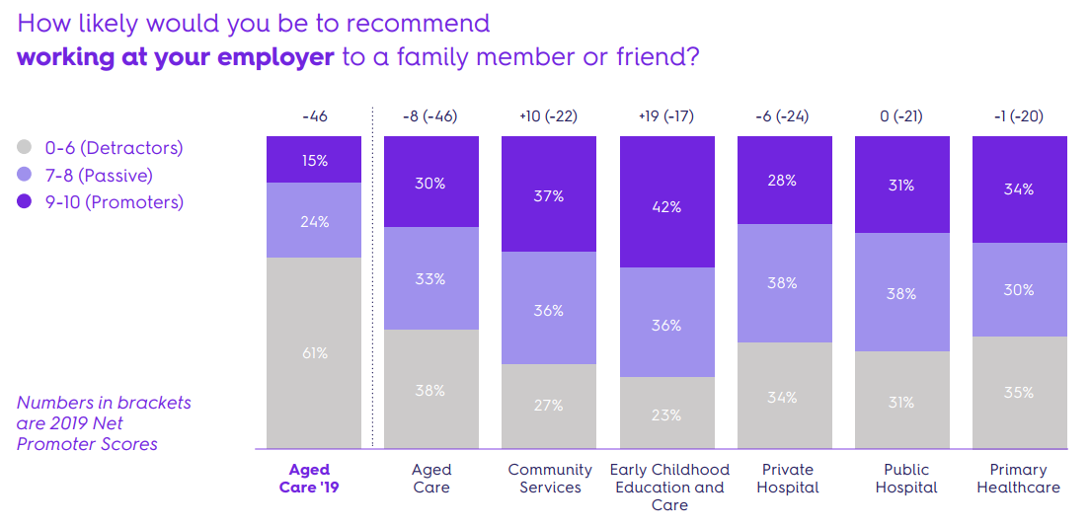
Why Care Friends
Using Care Friends for our employee referral is part of our sourcing strategy designed to grow referral as a reliable source, delivering good staff in meaningful numbers. Care Friends is a major redesign of the strategies and operation of referral schemes. It takes referring to the 21st century and makes it easy, fun and rewarding via the use of an app and microrewards.
The app
The app is designed to be straightforward to use but also with a bit of fun. When a job is made available, all app users get a notification. Jobs are easily shared from the home screen and app users can instantly see how many points they have collected in their money bag. Employees are kept up to date via notifications about their referral’s recruitment progress. Cashing in their points is also within their control.
And, for just downloading the app and registering, employees can automatically receive points.

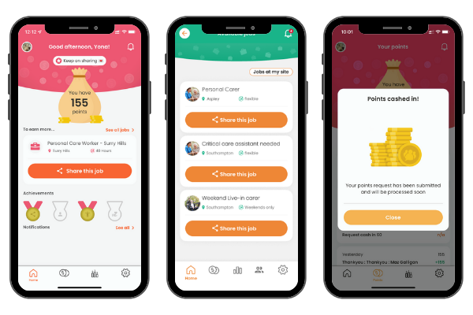

Referral rewards
Care Friends changes the way referrals are rewarded by using microrewards which are displayed as Care Friends points within the app. So instead of one large pay-out when a referral starts work, or reaches probation, Care Friends rewards are broken down into smaller chunks and paid out much sooner! For example:
1 point = $1
Sample Referral Rewards
Share a job 1 point
Referral applies 5 points
Referral has successful interview 25 points
Referral starts work 150 points
Referral stays in job for XX months 150 points
Referral is new to care 10 points

Breaking down the referral reward like this ensures that employees are rewarded timely for sharing jobs as well as for making quality referrals.
Every time a referral progresses through the recruitment stages, the referring employee receives a notification on their phone and for some milestones also receives the associated reward.

“We believe that great people know great people and we wanted to provide a platform for employees to easily refer friends and family. Care Friends is enabling us to create a culture of referring within Bolton Clarke.” Lee Robinson – Manager Talent Acquisition – Bolton Clarke
Care Friends for Recognition
Recognising and celebrating successes, big and small, is important in our sector. Care Friends can also be used for reward and recognition via the in-built Bonus Point functionality. Points can be awarded for any reason and are instantly added to the employee’s app.
Employees can be rewarded via bonus points which will be added to employees’ Care Friends app.
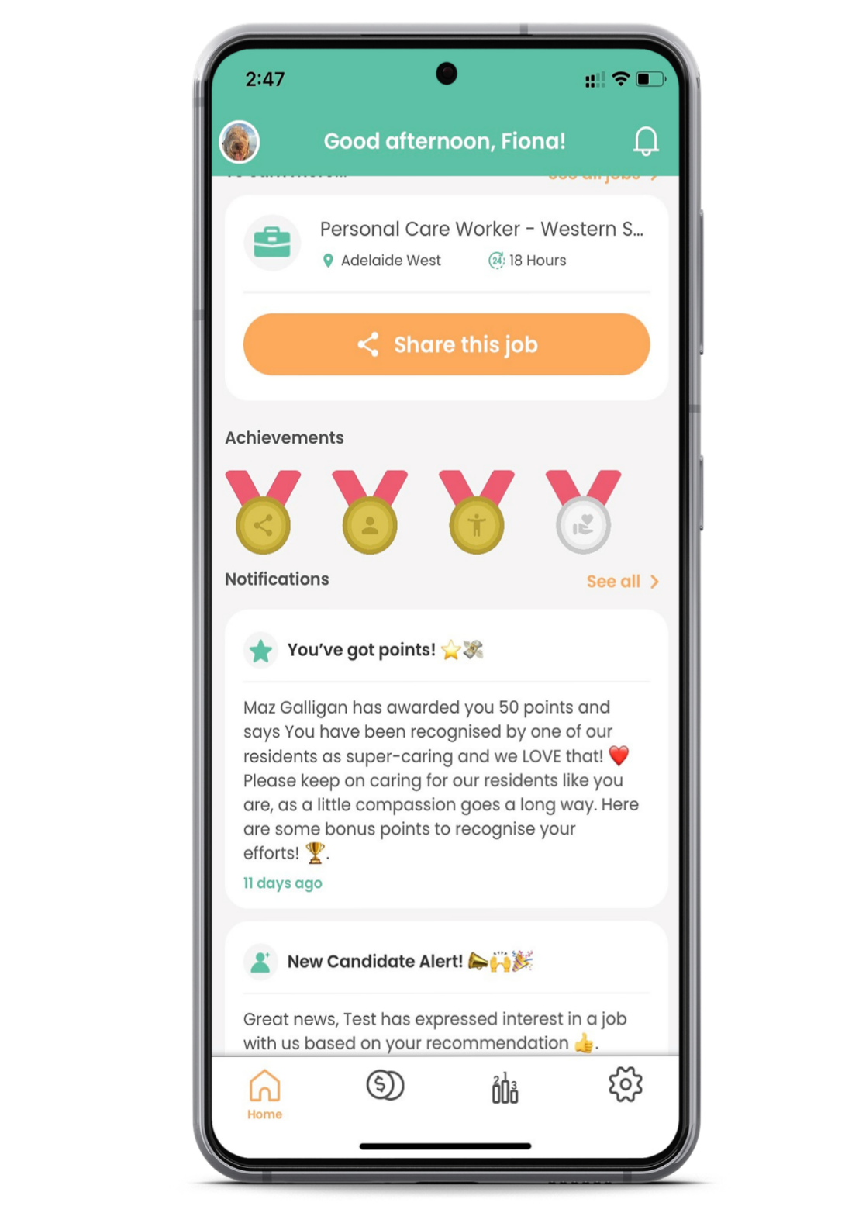

Cashing in points
Points that are collected either via referrals or bonus points can be requested to be cashed out at any time via the app when an employee reaches a minimum number of points.
Points are converted to dollars, where 1 point = 1 dollar and can for example, be paid out via payroll or VISA cards.

“It feels great to click on the money bag and choose how many points I want to cash in”
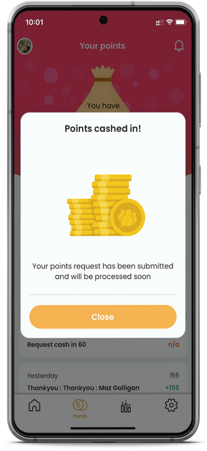
To make this a success
Ensuring the Care Friends is well embedded into the organisation, everyone has a role to play.
Employees
Recruitment can be everyone’s business. Referrals are of better quality and stay longer than new starters from other recruitment sources. And with longer tenure comes better care for clients/residents and less work pressure. Employees are urged to:
- Download and have fun with the app
- Share jobs with their network
- Ask for help from their local Champion
- Talk to their network about the jobs
- Talk to colleagues about the app
- Cash in and enjoy the rewards!
- Not game the system. This takes away precious screening time from recruiters
The Execs & Management
From a strategic perspective, increasing employee referrals and recognition of great work by employees is key to the continued success of the organisation. Execs and Management have invested in this program. They will need to:
- Walk the talk and promote the programs
- Download the app
- Communicate about and celebrate successes
- Award Bonus Points as per the policy
- Complete training (if relevant)

Champions
Local Care Friends Champions are the advocates of employee referral and experts in using the app. Champions are employees who are well-connected and often well-regarded at a site or department. They are responsible for:
- Helping with the launch and support employees with downloading and using the app
- Talk about the app and increase app sign up
- Answering specific questions
- Sharing successes and celebrate wins
- Be referral and recognition advocates
- Complete the training
Talent Team (or Admins at site)
Recruiters are often responsible for managing the employee referral program. Some key points for them are to:
- Help promote the app by sharing successes and celebrate wins
- Complete the training
- Support employees with downloading and using the app
- Answering specific questions
- Regularly share new jobs via the app
- Promptly push referrals through the recruitment stages
Payroll
Because or referral and recognition rewards are paid out via payroll, their role is just as important as anyone else’s. They too need to:
- Help promote the app
- Promptly add pay-out requests to the next pay run or via VISA cards.
How to download the app
There are several ways to get the Care Friends app on employees’ phone. We recommend downloading the app on your personal phone as that is where key contacts are

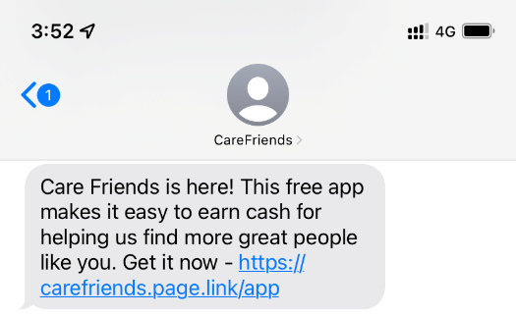
Via the text invite sent from Care Friends on launch day or at a later stage.

By scanning a QR code from within the on-boarding pack, or on flyers or posters etc and then either completing the self-registration form or downloading the app from the app store.

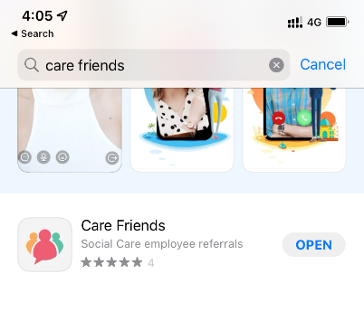
By searching for the Care Friends app in the app store.

