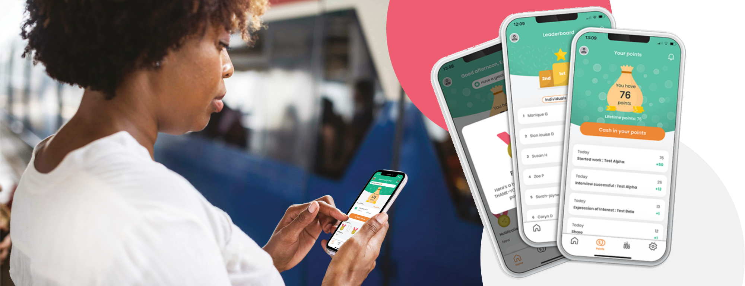

[Company Name] Staff
Referral & Reward Program

We are always looking for more amazing team members like you and we want to make it easy to recommend our jobs to people in your network. We also want to reward you for doing that!
So, on [DATE] we’re launching an employee referral and reward app, called Care Friends. Please be sure to have your personal mobile handy on the day! Care Friends is super simple to use and will make it much easier and more rewarding for you to share jobs and encourage your network to join our organisation.
How will we reward you?
Just for downloading the app, we will reward you with XX points. Simply start sharing jobs with your network and see your points grow. Make sure to share jobs with quality referrals, as for each step in the recruitment process they successfully complete, you get more points.
1 point is worth $1!
Action | Points
Download and register for the app | XX
Share a job | 1
Your referral applies | XX
Your referral has a successful interview | XX
Your referral completes their first day on the job | XX
BONUS if your referral is NEW to the care sector | XX
Your referral reaches XX months of employment | XX

Extra rewards!
We will also use Care Friends to give out rewards that are not referral-related. For example, our employee-of-the-month reward will now be paid out via Care Friends and our managers can give you extra points for excellent work. So that excellent feedback you recently received from one of your residents, could easily turn into extra cash. These are the categories for which we give out bonus points:
Action | Points
Excellent client feedback | xx
Going over and above | xx
Taking on a last-minute shift | xx
Helping a colleague in need | xx
Other, up to manager discretion | xx
Employee of the month | xx
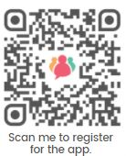
How to download the app?
- Wait for your text message invitation on [DATE]
- Download the app through your app store
- Scan this QR code ---------------------------------------------
Launch Day: [DATE]

What we need from you
To help us make this a success we ask you to:
- Download and have fun with the app
- Share jobs with your network
- Ask for help from your local Champion
- Talk to your network about working with us
- Talk to colleagues about the app
- Cash in and enjoy your rewards!
- Not game the system. We will know about it and it takes away precious screening time from our recruiters

