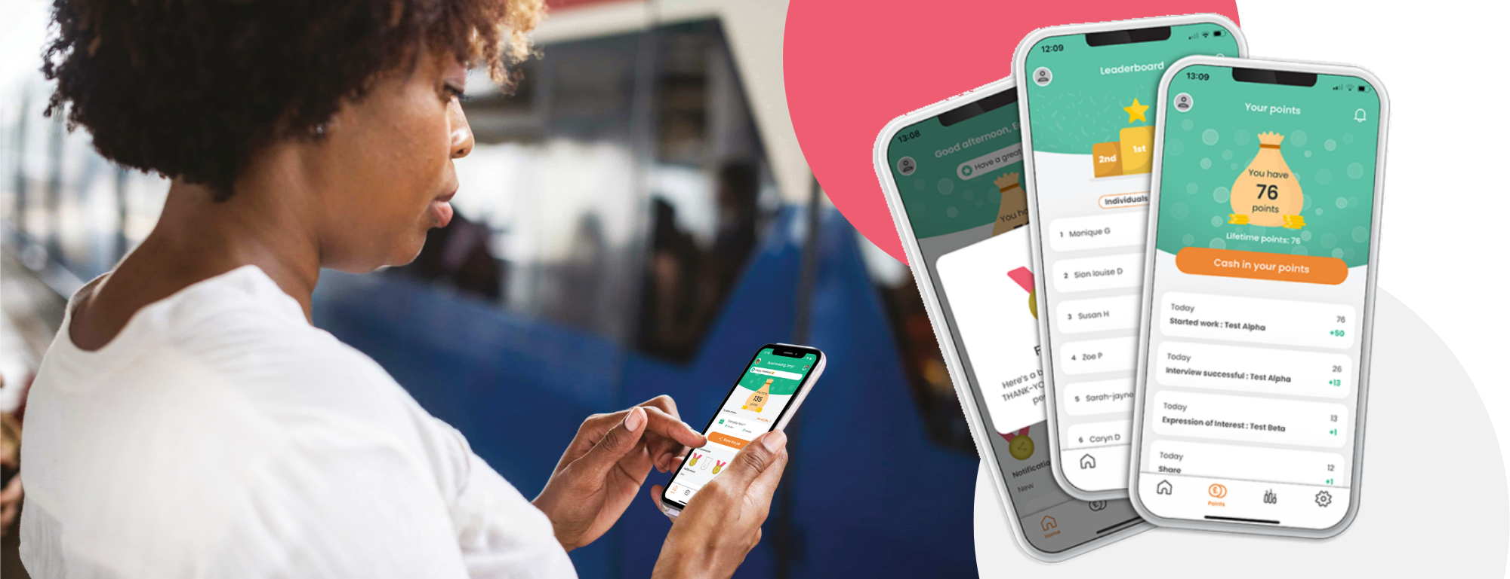

[Company Name] Staff
Referral & Reward Program

To our Care Friends Champions,
Caring People know Caring People
Firstly, thank you for being one of our Care Friends Champions! Being a Champion is a key part of this new initiative and with your help we can really turbocharge our employee referral program and ensure we find more great people like you!
Employee referrals are proven to be the best way to source quality staff with higher retention rates. Our own staff have vast networks of potential employees, and we want to tap into these.
As mentioned in an earlier email, we are going to turbocharge our referral scheme by launching Care Friends, a brand-new employee referral and reward app for the Care Sector. Care Friends makes it super easy for our staff to share jobs plus fun and rewarding.
We would rather reward our own staff for candidates, than online job boards or agencies.
Watch the short intro video

- Please note that we need your help and have more detail further down this email. Please watch the video and keep on reading for all the detail.

How will we reward referrals?
Just for downloading the app, we will reward staff with XX points. Care Friends uses micro-rewards to promote quality referrals, so for each step in the recruitment process a referral successfully completes, the referrer gets more points.
1 point is worth $1!
Action | Points
Download and register for the app | XX
Share a job | 1
Your referral applies | XX
Your referral has a successful interview | XX
Your referral completes their first day on the job | XX
BONUS if your referral is NEW to the care sector | XX
Your referral reaches XX months of employment | XX

Once an employee reaches XX points, they can choose to cash in these points and the value of the points will be added to their next pay (minus any applicable taxes or deductions).

Launch Day: [date]

Who will manage referrals?
Employee referrals will be managed by our central Talent Team. Nothing will change for you in the recruitment process. As always, we will need your support by being available to interview candidates and provide feedback after the job interview as soon as possible. In this candidate scarce market, time is of the essence.
Employee referrals will be managed by a dedicated person at each of our locations. Care Friends comes with its own referral platform, connected to the employee app, that makes managing jobs and referrals a breeze. More info and training for this person will follow.
As we have integrated the Care Friends app with our ATS [ATS NAME], referrals will pop in there as per the normal recruitment process. We just want to reinforce the importance of timely updates to the candidates’ recruitment status, as these updates are now directly linked to the allocation of points to the referring employee via the app.

Extra rewards!
We will also use Care Friends to give out rewards that are not referral-related. We call them Bonus Points. For example, our employee-of-the-month reward will now be paid out via Care Friends.
As a Care Friends Champion, we have added in some additional rewards to recognise your efforts and support. Every Champion will get XX points (which equals $XX) just for being a Champion. However, you can get more $$ for reaching certain milestones.

Action | Points
Being a Care Friends Champion and attending the info session/completing the e-learning module | xx
When 20% of employees at your site have registered for the app | xx
When 40% of employees at your site have registered for the app | xx
When 60% of employees at your site have registered for the app | xx
When 90% of employees at your site have registered for the app | xx

You can increase the number of colleagues at your site who download the app by:
- Helping download the app during and after the launch
- Talking to your colleagues about Care Friends
- Answering questions colleagues might have
- Work with your manager to celebrate referral success (for example, recognising the first new starter who came in via referral or by running an internal referral competition).

How to download the app?
On launch day, all eligible employees will receive a text message on their personal mobile with a link to the app. Alternatively they can download the app from their app store or scan a QR code that we provide them with. We recommend you download the app as well.

Who is eligible?
- All permanent, part-time, casual staff are eligible to refer as long as they are not directly involved in the recruitment process for the job

Some rules
- No internal referrals
- The referral must be qualified and eligible for the role
- If a candidate is ineligible, awarded points may be deducted
- The referral must live within a reasonable commutable distance to the job
- Must not have applied for a role with us in the past 6 months
- You can choose to cash-in your points once you reach XX points
You can view all rules from within the app.

Champions Training
On [DATE] and [DATE] we will run a 30-minute Care Friends Champions information sessions with more info. Please choose one of these sessions to attend and mark it in your calendar.
Soon you will receive an invite for a quick e-learning module on being a Care Friends Champion and how to use the Care Friends app. Please ensure that you complete this module before launch day.

Thank you in advance for making a success of this important new resource!

