The Referral Process

Creating Jobs 2
Activate a new job to send it out to all App Users 3
Receiving EOIs 4
Call the referral to check eligibility 4
Ineligible 4
Eligible 5
Move the candidate through the referral screens 5
Support 6

Creating Jobs
We have a created a job template in your Care Friends Portal. The quickest way to create a new job is by duplicating the job template and changing a few parameters, such as job title, position description etc.
Click on Jobs in the menu on the left.
Click on the 3 dots on the right-hand side of that job template
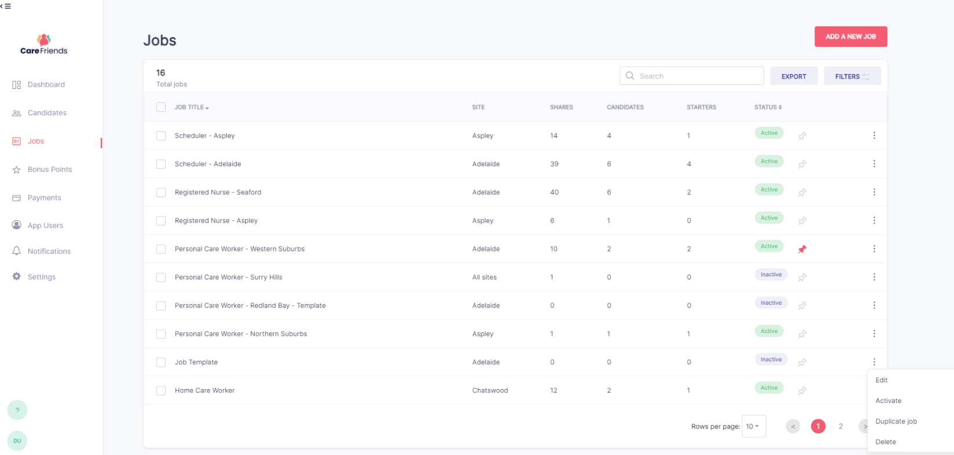
Choose Duplicate

Please note the pink pin next to a job.
This feature pins that job to the app dashboard to highlight the job.

Now that you’ve duplicated the template, it’s time to edit it!
Click on the 3 dots on the right-hand side of that duplicated job template
Choose Edit and change all required fields to match your actual job

Although you’ve now created a new job, it is not yet active….
Activate a new job to send it out to all App Users
Once you have completed the duplicating job process you need to
Activate the job for a notification to be sent to all app users.
Click on the 3 dots for the new job that you have created
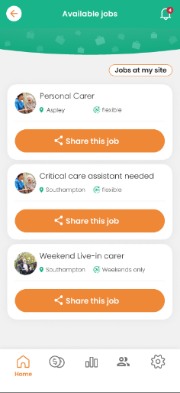
Select Activate
This sends a notification to all app users that a new job is available to share.

- Remember to deactivate when the job is no longer available.

Receiving EOIs
When someone expresses interest in a job, an email will be sent to the nominated person attached to that job (this is set up when creating a new job).
Best practice is to contact the referral as soon as possible (within the hour) by phone. Referrals are generally considered of “higher quality” than many other recruitment sources and a VIP treatment is recommended.
Call the referral to check eligibility
When calling the referral, we recommend you first check if they are an eligible referral before checking if they are suitable for the job. Your scheme rules dictate that the referral must be:
- Not an internal candidate
- Not previously referred in the last 6 months
- Qualified if necessary and lives within a reasonable distance to the job
At the end of this call determine if this referral is eligible to proceed or is deemed ineligible.
Ineligible
Click on Candidates in the left-hand menu
Click on the Contact Made stage and choose Ineligible (please note the other options)
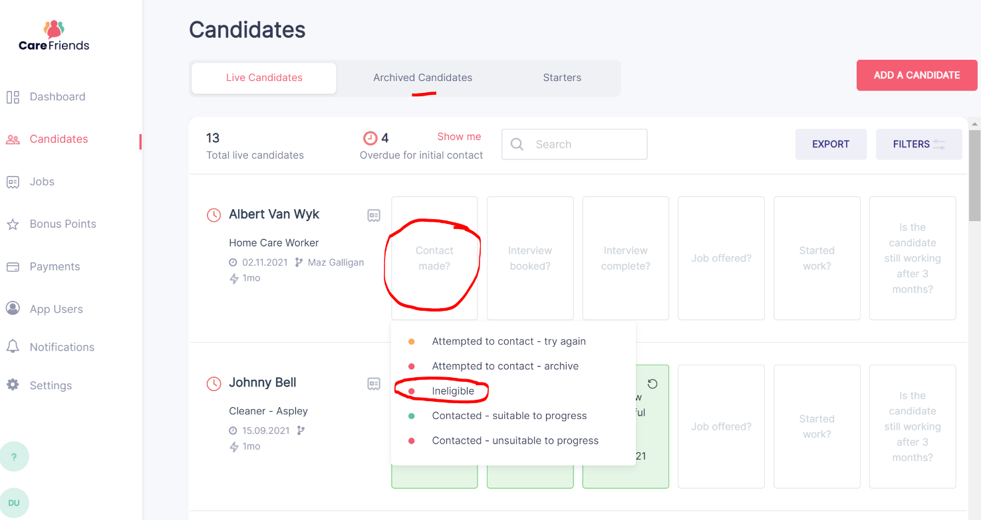
This will move the referral into the Archived Candidates tab and out of your way. The referring employee will automatically get a notification to advise their referral was unsuitable. Done!

Eligible
First contact HR and advise them you have a candidate moving forward to interview. That will initiate HR to contact the applicant and ask them to formally apply through Page-Up to get them into the system and obtain a resume.
Move the candidate through the referral screens
You can now move your referral through the candidate screen in the Care Friends portal. Best practice is to update these steps closely in line with the actual steps in the recruitment process. Be aware that many of these boxes automatically send notifications to the referee and three of them will incur referral points:
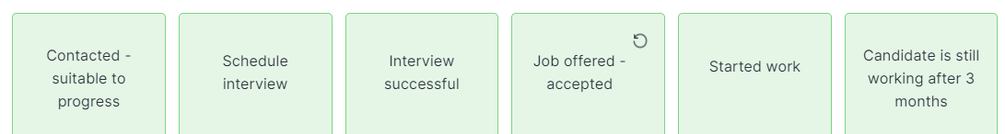
Continue following your normal recruitment process liaising closely with HR and the hiring manager. Be sure to keep your eye on the referral and continue ticking through the stages in the candidate screen.
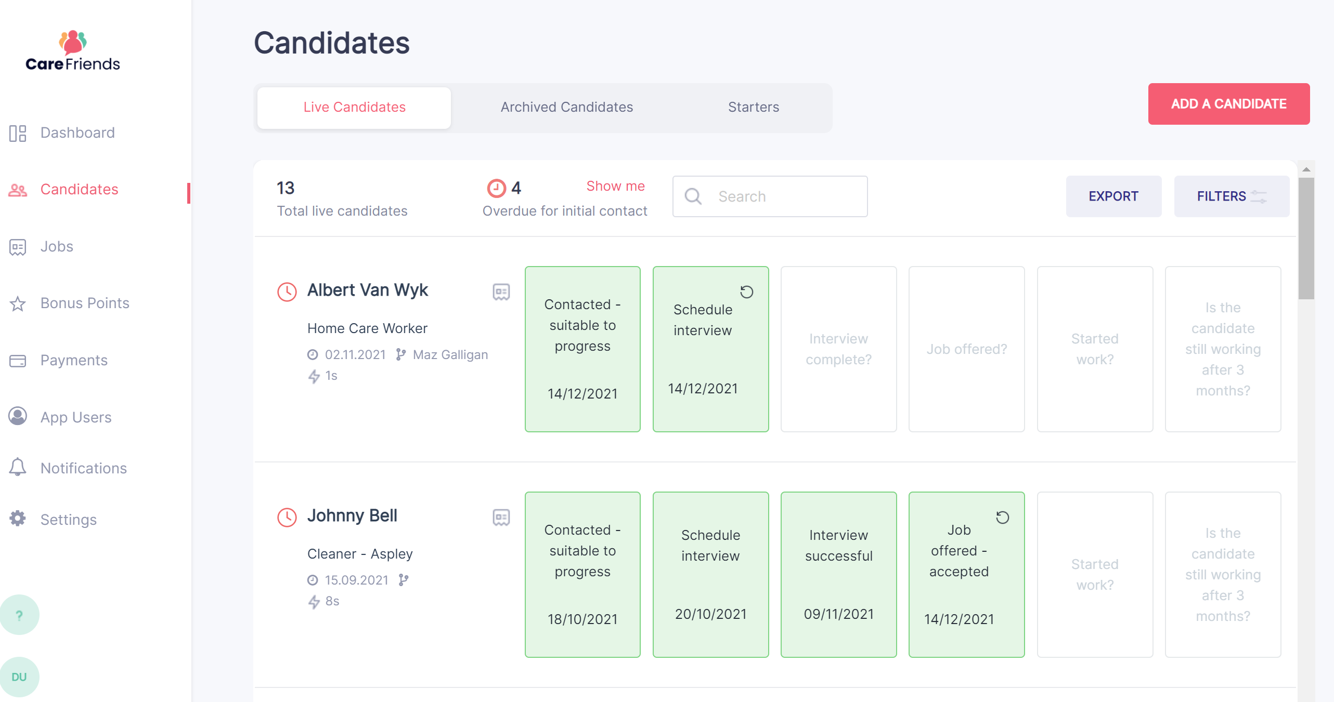
Once the candidate “started work” they will move into the Starters tab at the top of the screen.
The final box Is the candidate still working after X months? doesn’t need to be completed until that retention period is achieved. Don’t worry, you will automatically receive an email at that time to remind you! Please tick this box at that time which will then awards more points and notifications to the referee. If they have left the job, you can select ‘no’.
Support
We have a substantial knowledge base/support tab within the portal. Here you will find all things Care Friends at an operational level, such as:
- Manually adding a referral
- What to do with multiple expressions of interest from the same referral
- How to delete a referral
- How to move a referral out of the archive
- How to undo a candidate update
- What to do with payment requests
- How to remove points
Or have a look at the complete recruiter guide

Click on the question mark in the bottom left-hand corner to reach our full knowledge base. Also feel free to reach out to us directly on info@carefriends.com.au
