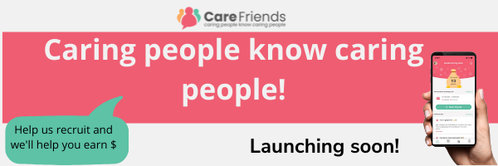

More Detailed Comms – 1 or 2 weeks before launch (after teaser information is distributed)

It’s people like you who make our company special, who enable us to do the very important job we do, every day. We’re always looking for more amazing team members; people who will make a difference to our clients, providing them with the best possible care.
You will already have a network on social media and friends and family who could make great care staff. We want to make it simple for you to recommend us as a great place to work. So to make it easier for you to refer people to us, we’re launching a new employee referral app called Care Friends. Care Friends will make it much more convenient for you to encourage your network to join us. It’s easy to do. Simply wait for your text invitation on launch day! (or provide other instructions if necessary)

Once that’s done, you can start earning. Simply share a job with your friends and you’ll start to earn points. More points will apply if they apply, attend an interview, if they get a job, start work and if they stay in the role for a certain time. You can earn points in other ways too, just by supporting your company or clients.
Being a Care Friend is easy. It will help us grow our team and enable us to support more people who need our help whilst putting extra cash in your pocket.

Launch date….

Add referral rewards available:

Job Share ?
Expression of Interest ?
Successful Interview ?
Job Started ?
Reached Job Milestone?

Add a few Scheme rules, for example
- No internal referrals
- Must be qualified for the role they are applying for
- Must not have applied in the last 6 months
- Can cash out once reached 50 points or over

