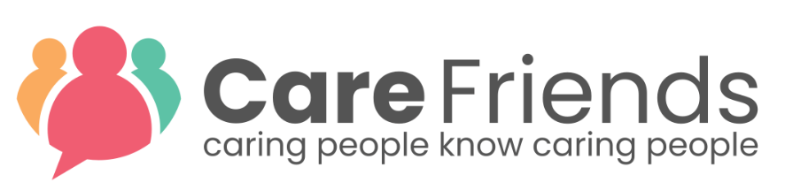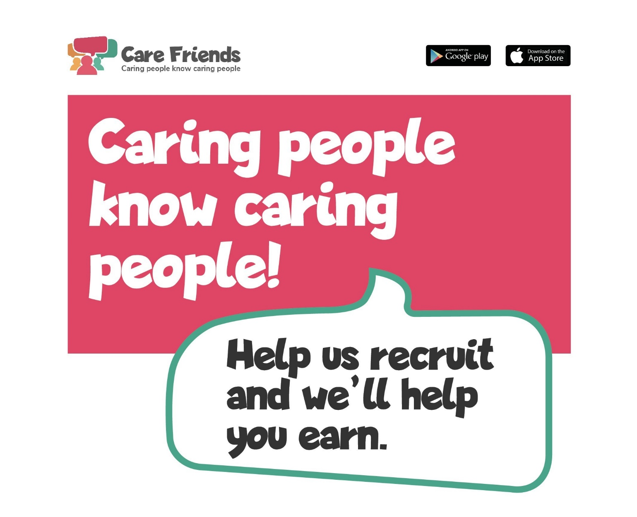

It’s people like you who make our company special, who enable us to do the very important job we do, every day. We’re always looking for more amazing team members; people who will make a difference to our clients, providing them with the best possible care.

We are trialing something new!
Watch this space more information soon.
Launching soon.

