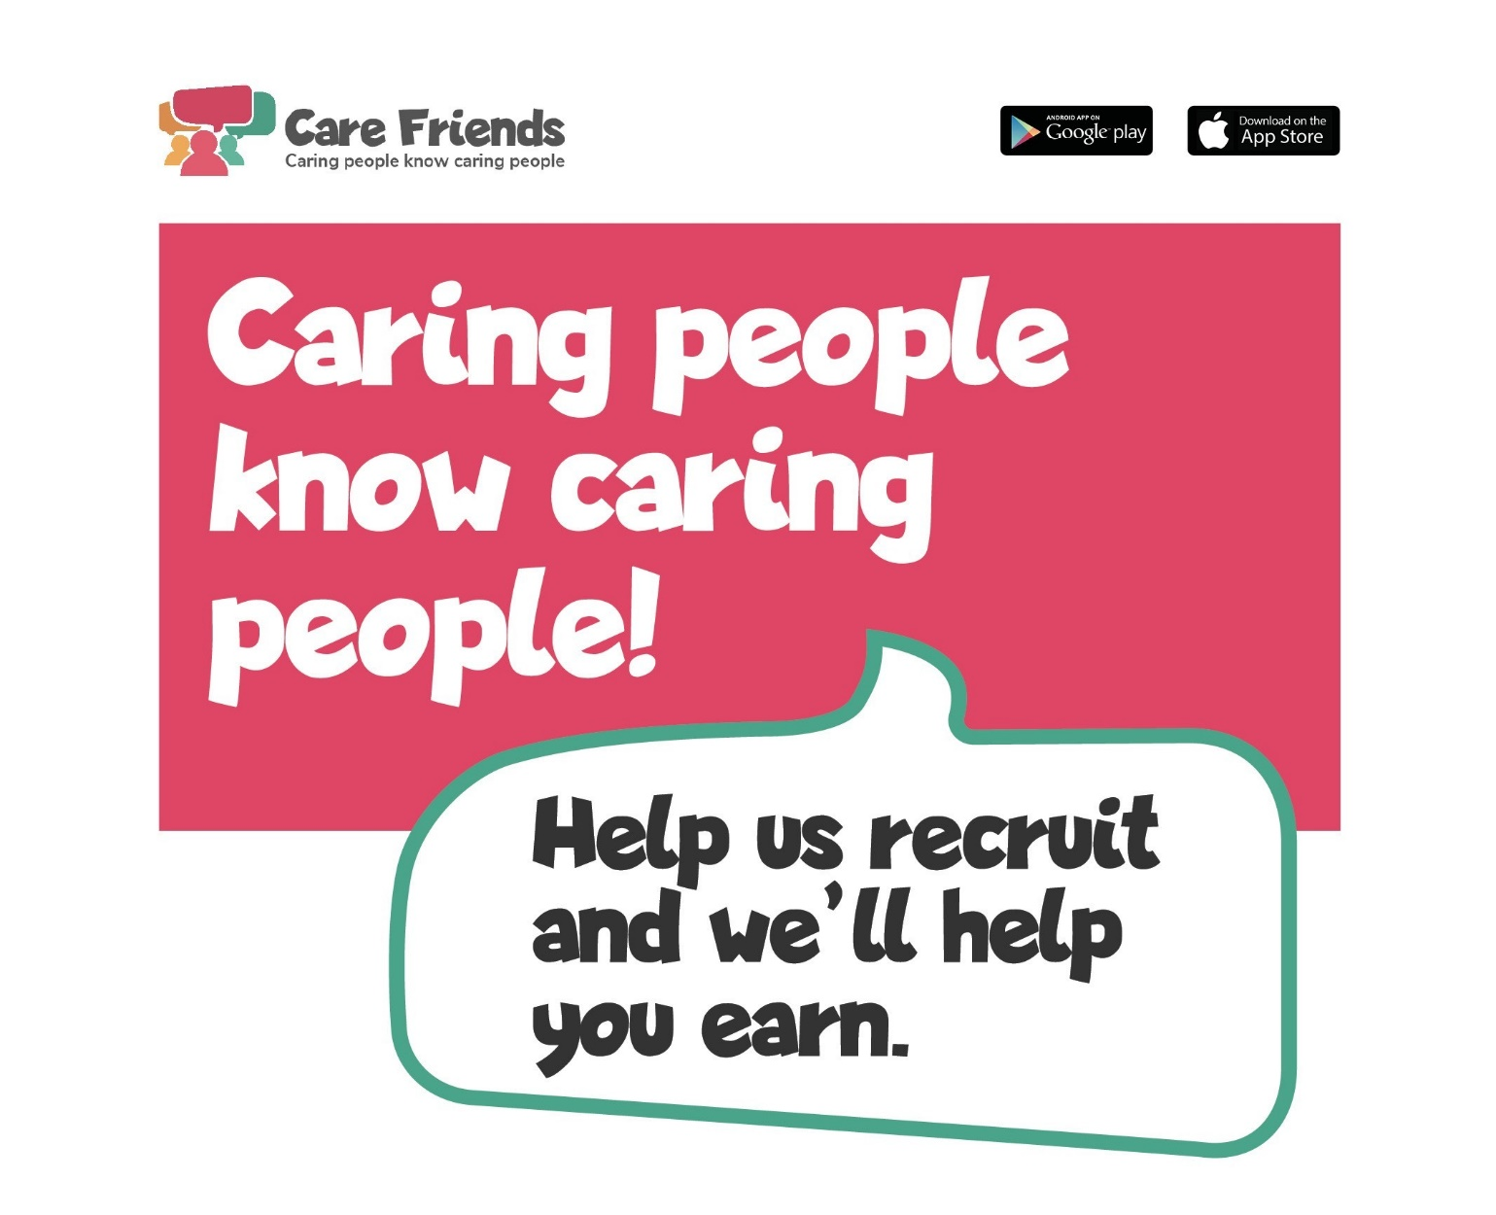
It’s people like you who make our company special, who enable us to do the very important job we do, every day. We’re always looking for more amazing team members; people who will make a difference to our clients, providing them with the best possible care.

You will already have a network on social media and friends and family who could make great care staff. We want to make it simple for you to recommend us as a great place to work. So to make it easier for you to refer people to us, we’re launching a new employee referral app called Care Friends. Care Friends will make it much more convenient for you to encourage your network to join us.

Once that’s done, you can start earning. Simply share a job with your friends and you’ll start to earn points. More points will apply if they apply, attend an interview, if they get a job, start work and if they stay past probation. You can earn points in other ways too, just by supporting your company or clients.

Being a Care Friend is easy. It will help us grow our team and enable us to support more people who need our help whilst putting extra cash in your pocket.

Contact your HR department to download the app today and start earning right away.

