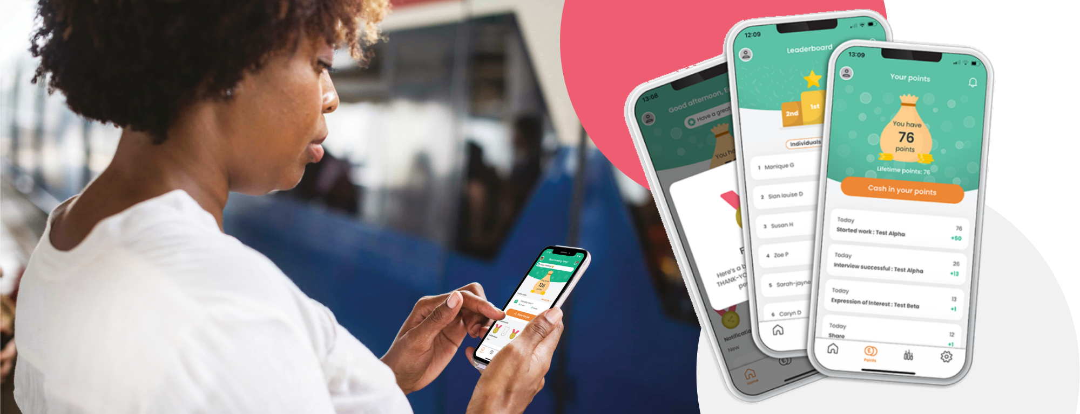

[Company Name] Staff
Referral & Reward Program

To our Managers,
Caring People know Caring People
Employee referrals are proven to be the best way to source quality staff with higher retention rates. Our own staff have vast networks of potential employees, and we want to tap into these.
As mentioned in an earlier email, we are going to turbocharge our referral scheme by launching Care Friends, a brand-new employee referral and reward app for the Care Sector. Care Friends makes it super easy for our staff to share jobs plus fun and rewarding.
Watch the short intro video

Morning Tea Info
On [DATE] we will launch Care Friends and that morning all eligible employees will receive a text message invite on their personal phones. Although we cannot control the exact time these text messages arrive, most employees will receive it that morning between 9am and 11am.
To add a bit of oomph to the launch, we will provide you with some treats to host a morning tea for all available employees. During the morning tea, we need your help by introducing Care Friends to your team. To help you with this, we have created a short presentation with notes that you can show to your team. We also ask you to download the Care Friends app before this meeting and familiarise yourself with it.
One of your team members – [NAME HERE] - is your Care Friends Champion. They will have a bit more knowledge about the app and are available to employees to help them download and navigate the app.
As we will also use Care Friends for our reward and recognition program, you may be required to do some training on how to use the Care Friends manager portal to assign these extra points (Bonus Points).
A previous email included more detail on Care Friends but feel free to contact us directly if you have any further questions.

Thank you in advance for making a success of this important new resource!

