Our new employee referral and recognition programs
Why Referral
None of us need reminding about the challenge of finding frontline staff and the resultant shifts left vacant or filled by agency staff. For many of our frontline positions, job boards are not delivering the number or quality of staff required, so alternative sources need to be found. Employee referral is not new, nor has it been user friendly for the business or staff and as a result it is seriously underutilised.

The latest Hesta Aged Care Workforce Insights (2021) shows 30% aged care staff would recommend working at their employer to a family member or friend. A further 33% would not rule it out. We now have an opportunity to effectively target these groups and to access a virtually exclusive use candidate pool.
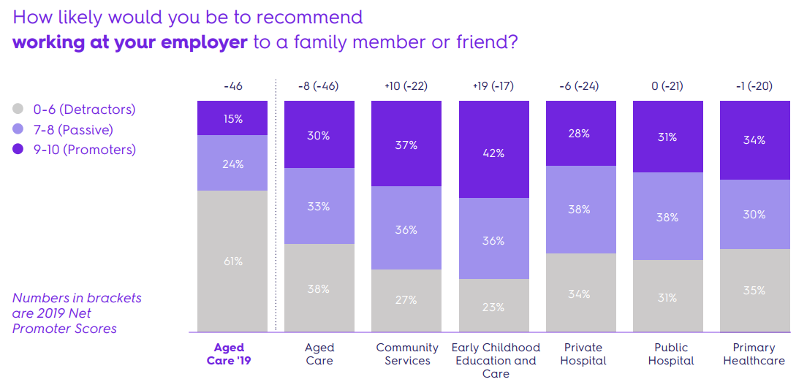
Why Care Friends
Using Care Friends for our employee referral is part of our sourcing strategy designed to grow referral as a reliable source, delivering good staff in meaningful numbers. Care Friends is a major redesign of the strategies and operation of referral schemes. It takes referring to the 21st century and makes it easy, fun and rewarding via the use of an app and microrewards.
The app
The app is designed to be straightforward to use but also with a bit of fun. When a job is made available, all app users get a notification. Jobs are easily shared from the home screen and app users can instantly see how many points they have collected in their money bag. Employees are kept up to date via notifications about their referral’s recruitment progress. Cashing in their points is also within their control.
And, for just downloading the app and registering, the employees automatically receive XX points.

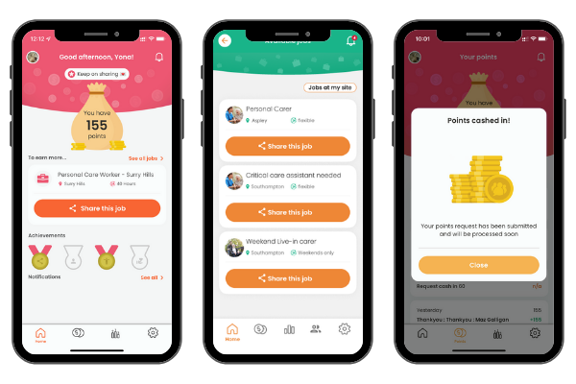
Referral rewards
Care Friends changes the way referrals are rewarded by using microrewards which are displayed as Care Friends points within the app. So instead of one large pay-out when a referral starts work, or reaches probation, Care Friends rewards are broken down into smaller chunks and paid out much sooner! For example, in our case this is:
1 point = $1
Our Referral Rewards
Share a job 1 point
Referral applies 5 points
Referral has successful interview 25 points
Referral starts work 150 points
Referral stays in job for XX months 150 points
Referral is new to care 10 points

Breaking down the referral reward like this ensures that employees are rewarded timely for sharing jobs as well as for making quality referrals.
Every time a referral progresses through the recruitment stages, the referring employee receives a notification on their phone and for some milestones also receives the associated reward.

“We believe that great people know great people and we wanted to provide a platform for employees to easily refer friends and family. Care Friends is enabling us to create a culture of referring within Bolton Clarke.” Lee Robinson – Manager Talent Acquisition – Bolton Clarke
Our Recognition Program
Recognising and celebrating our successes, big and small, is important. Our work in this sector is so fulfilling but can be very hard at times. We understand that and see the effort we all put in to caring for our clients, residents, colleagues and organisation.
Going forward, we will also use Care Friends for our Reward and Recognition program. Employees can be rewarded via bonus points which will be added to employees’ Care Friends app.
These are the reward categories we use and how we reward these:
Our Reward and Recognition Categories
Going over and above 20 points
Great feedback from client 20 points
Employee of the month 20 points
Birthday 20 points

[perhaps include some more information about your Reward and Recognition Program].

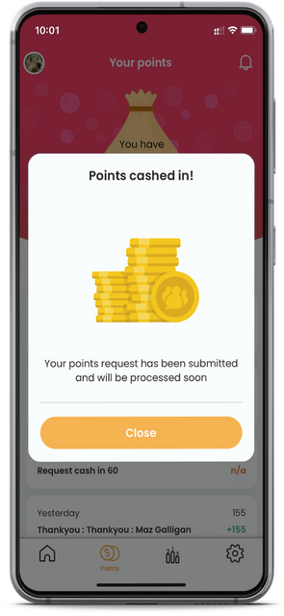
Cashing in points
Points that are collected either via referrals or bonus points through our reward and recognition program can be requested to be cashed out at any time via the app when you reach a minimum of XX points.
Points are converted to dollars, where 1 point = 1 dollar and paid out via payroll/our VISA card program/etc. Any relevant taxes and deduction will be applicable.

“It feels great to click on the money bag and choose how many points I want to cash in”

To make this a success
Although cliché, we are all in this together. Everyone has their part to play in ensuring that our new referral and recognition programs are a success.
Employees
We want to make recruitment everyone’s business and reward our employees for doing so. Referrals are of better quality and stay longer than new starters from other recruitment sources. And with longer tenure comes better care for our clients/residents and less work pressure. To help us make this a success we urge you to:
- Download and have fun with the app
- Share jobs with your network
- Ask for help from your local Champion
- Talk to your network about working with us
- Talk to colleagues about the app
- Cash in and enjoy your rewards!
- Not game the system. We will know about it and it takes away precious screening time from our recruiters
The Execs & Management
From a strategic perspective, increasing employee referrals and recognition of great work by our employees is key to the continued success of our organisation. Our Execs and Management have invested in this program. They will need to:
- Walk the talk and promote the programs
- Download the app
- Communicate about and celebrate successes
- Award Bonus Points as per our policy
- Complete training (if relevant)
Champions
Our local Care Friends Champions are our advocates of employee referral and experts in using the app. Champions are employees who are well-connected and often well-regarded at a site or department. They are responsible for:
- Helping with the launch and support employees with downloading and using the app
- Talk about the app and increase app sign up
- Answering specific questions
- Sharing successes and celebrate wins
- Be referral and recognition advocates
- Complete the training
Talent Team (or Admins at site)
Our recruiters will be responsible for managing our employee referral program. Some key points for them are to:
- Help promote the app by sharing successes and celebrate wins
- Complete the training
- Support employees with downloading and using the app
- Answering specific questions
- Regularly share new jobs via the app
- Promptly push referrals through the recruitment stages
Payroll
Because or referral and recognition rewards are paid out via payroll, their role is just as important as anyone else’s. They too need to:
- Help promote the app
- Promptly add pay-out requests to the next pay run
How to download the app
There are several ways to get the Care Friends app on your phone. We recommend downloading the app on your personal phone as that is where your contacts are.
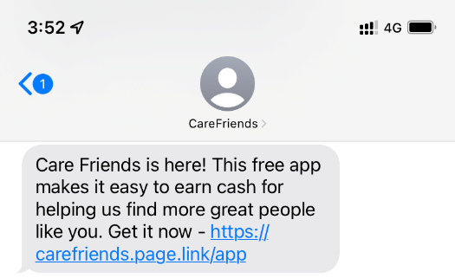
Via the text invite sent to you from Care Friends on launch day or at a later stage. If you receive the text invite, this means that you have already been pre-authorised to download the app and all you have to do is follow the prompts. It’s quick and easy. Please make sure to enter your personal phone number and work email.

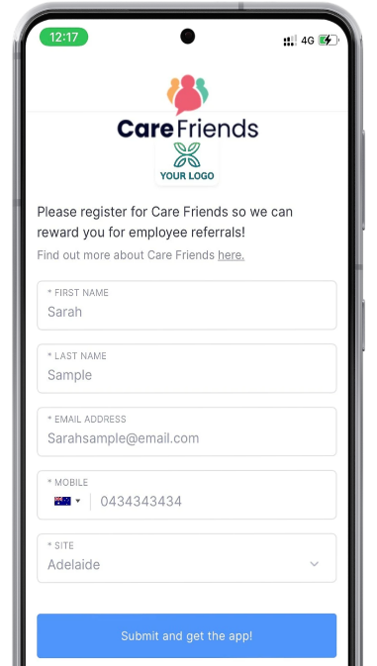
By scanning a QR code from within your on-boarding pack, on one of our flyers or posters etc. Make sure to scan this code with the phone you want to download the Care Friends app onto. This can take you to one of two places:

A self-registration form which enables you to authorize and register yourself to the app and then download it.
The Care Friends app in either the Android or Apple App store from where you can download the app. Once downloaded you must use the same details used to pre-authorise you, so you might have to contact your Champion or the People Team to find out what that is. In most cases you would have been pre-authorised with your personal phone number and work email.
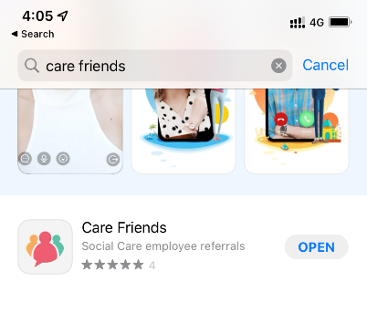
By searching for the Care Friends app in your phone’s app store. Once downloaded you must use the same details used to pre-authorise you, so you might have to contact your Champion or the People Team to find out what that is. In most cases you would have been pre-authorised with your personal phone number and work email.

